SUSHI TANGO SCHOLARSHIP
2016 APPLICATION PACKET

PRESENTED BY
THE HMONG AMERICAN EDUCATION FUND
www.thehaef.org

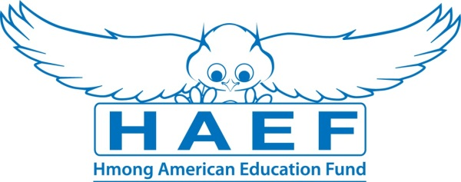

This scholarship was made possible and donated by Mr. & Mrs. Pao Thao.

Instructions for the Sushi Tango Scholarship
This scholarship is presented by the Hmong American Education Fund and donated by Mr. & Mrs. Pao Thao, owners of Sushi Tango restaurant. The scholarship seeks to financially support two dedicated Hmong-American students in the pursuit of their higher educational goals. The successful applicants will be awarded up to $500 each to the choice of his/her college or university. Download this application packet and fill out the form below. All application materials are due by March 15, 2016. Late applications and materials will not be considered. Any hand written application will be disqualified. All application materials must be sent in PDF format via E-mail to: scholarships@thehaef.org. You will be notified of your application status via E-mail by May 30, 2016
Applicants Must Meet All Criteria Listed
- A U.S. citizen or legal resident alien.
- Will be attending an accredited private/public college or university.
- Any person of Hmong descent pursuing an education to better himself or herself and others.
- A Minnesota state resident.
- A high school senior or has earned a high school or GED diploma.
- Has been accepted fulltime to a 2-year or 4-year college/university in the Fall 2016 – 2017 academic year.
- Has a minimum GPA of 3.0 in a 4.0 scale system.
Scholarship Application Packet, Checklist
- A completed application.
- Essay (1500 words or less).
- Copy of unofficial transcript.
- One letter of recommendation.
- All required application documents should be sent in PDF format via E-mail to scholarships@thehaef.org
A Successful applicant must demonstrate the following
- A commitment to excellent academic achievement.
- A commitment to helping your community.
- Demonstrates financial needs, difficulties or hardships.
Essay: In one essay, 1500 words or less, please answer the following questions
- Tell us about your commitment to education.
- Tell us some of the things you have done to help your community.
- Tell us your needs and how this scholarship can help you.
Additional Requirements
- Recipients are expected to attend the Scholarship Awards Banquet on the first Saturday of August 2016.
- If selected, recipients are expected to submit the documents requested for the Scholarship Awards Banquet (ex. photo, bio, thank you letter to donors).
Successful applicants are required to attend two general academic coaching, and mentoring sessions with HAEF. These sessions can be done via phone, e-mail or face to face.
( If you have any questions, please email: scholarships@thehaef.org )

SUSHI TANGO SCHOLARSHIP
2016 Application (fill out application & save as PDF & E-mail back to scholarships@thehaef.org)
Last Name: | First Name: |  |  |  | Middle:
Address:
City: | State: |  |  |  | Zip Code:
Home Phone: | Cell Phone: |  |  |  | E-Mail:
Gender: | Date of Birth:
Name of Parent/Guardian: |  |  |  |  | Phone:
When did your family come to the U.S.? |  |  |  | State of resident:
Are you a U.S. citizen? |  |  | Are you a legal resident alien?
Parent’s annual house hold income, please give range:

If you are living on your own, list your annual house hold income:

List any savings, investments and inheritance:

How many languages can you speak, read, and write?

Name of your High School/GED:

School Address:

GPA: |  |  |  | ACT/SAT Scores:
Names of colleges you have been accepted to:

Major or area of study: |  |  |  | Will you be a fulltime student?
Are you or will you be applying to other scholarships or financial assistance? (If yes, please list them):

Have you been awarded other scholarships or financial assistance? (If yes, please list them):

Print Name: |  | Signature: |  |  |  | Date:
Disclaimer: By signing this application I understand that the information provided is true to the best of my knowledge. HAEF reserve the right to verify information submitted on the successful candidate’s application. In addition, the views and opinions expressed by individuals and/or businesses featured in our scholarships do not necessary represent the views of the Hmong American Education Fund.

