CHERZONG V. VANG
IN LOVING MEMORY OF CHERZONG VANG - THAJKHU VAJ TXIAB
APPLICATION PACKET
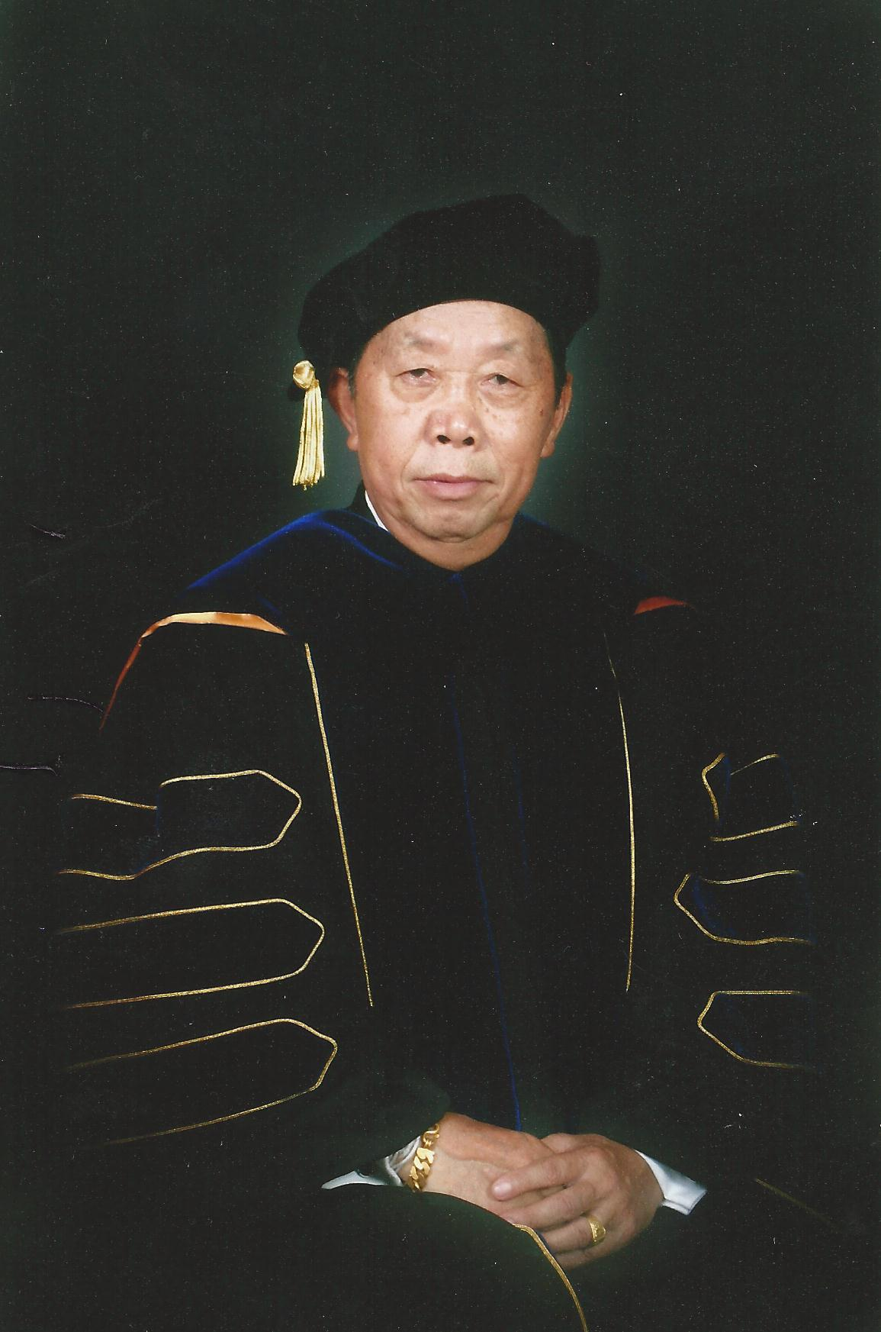

PRESENTED BY
THE HMONG AMERICAN EDUCATION FUND
www.thehaef.org

This scholarship was donated by Cherzong V. Vang’s children and his endowment in loving memory of Cherzong Vang (Thajkhu Vaj Txiab).

Biography provided by the family. If you like a copy please email: scholarships@thehaef.org

Instructions for the Cherzong V. Vang (Any Discipline) Scholarship
This scholarship is presented by the Hmong American Education Fund. This is a merit scholarship that seeks to financially support two students in the pursuit of their educational goals. The successful applicants will be awarded up to $500 each to the choice of their college or university. Download this application packet and fill out the form below. All application materials are due by April 15. Late applications and materials will not be considered. Any hand written application will be disqualified. All application materials must be sent by email to: hmongeducationfund@gmail.com. You will be notified of your application status via email by June 1.
Applicants Must Meet All Criteria Listed
- A U.S. citizen or legal resident alien
- Any state resident
- All students, race, nationalities, or ethnic backgrounds are eligible for this scholarship
- Any high school senior, high school or GED graduate or current college/graduate student is eligible
- Has been accepted fulltime to a 2-year or 4-year college/university or graduate school
Scholarship Application Packet, Checklist
- A completed application.
- Essay (1500 words or less)
- Copy of unofficial transcript
- One letter of recommendation
- All required application documents should be sent in PDF format via email to hmongeducationfund@gmail.com
A Successful applicant must demonstrate the following
- Pursue an education to better themself and others
- A commitment to excellent academic achievement
- A commitment to helping your community
Essay: In one essay, 1500 words or less, please answer the following questions
- Tell us about your commitment to education
- Tell us your knowledge of the Hmong People
- Tell us some of the things you have done to help your community outside of school
Additional Requirements
- If the recipient is from Minnesota, he/she is expected to attend the Scholarship Awards Banquet on the first Saturday of August.
- If selected, recipients are expected to submit the documents requested for the Scholarship Awards Banquet (ex. Photo, bio, thank you letter to donors)
Successful applicants are encouraged to attend two general academic coaching and mentoring sessions with HAEF. These sessions can be done via phone, e-mail or face to face.
( If you have any questions, please email: scholarships@thehaef.org )

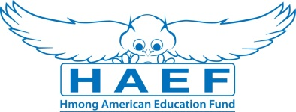
Cherzong Vang Scholarship Application
(Type responses below & email back to hmongeducationfund@gmail.com along with all other required documents in PDF)
Last Name: | First Name: |  | Middle:
Home Phone: | Cell Phone: |  | E-Mail:
Gender:  Female Male | Date of Birth (mm/dd/yyyy): |  | Race/Ethnicity:
Current Address:

City: | State: |  | Zip Code:
Permanent Address (if different from above):

City: | State: |  | Zip Code:
Check one of the following:  U.S Citizen  Legal Alien Resident of U.S.  None | Are you a first generation student?  Yes  No |  | Marital Status:  Single  Married  Divorced  Widowed
Number of parent(s): | Family size: |  | Number of dependents (if applicable):
Are you currently in high school or pursuing your GED?
Yes
No
Name of your current School: |  |  | Current GPA:
School Address:

Name of College/University you have been accepted to and/or will be attending:

Major/Program:

Degree you are seeking: Associate BA/BS Masters PhD/Doctorate Other:

What year of schooling are you in: First Year Sophomore Junior Senior

Will you be a Fulltime Student: Yes No
Have you been awarded other scholarships or financial assistance? (If yes, please list them):

Print Name: |  | Signature: |  | Date:
Disclaimer: By signing this application I understand that the information provided is true to the best of my knowledge. HAEF reserve the right to verify information submitted on the successful candidate’s application. In addition, the views and opinions expressed by individuals and/or businesses featured in our scholarships do not necessary represent the views of the Hmong American Education Fund.

