DR. KOU BLIAXA VANG & NIAM DR. KOU (SONG LEE VANG)
LIVING LEGACY SCHOLARSHIP – ANY DISCIPLINE
APPLICATION PACKET
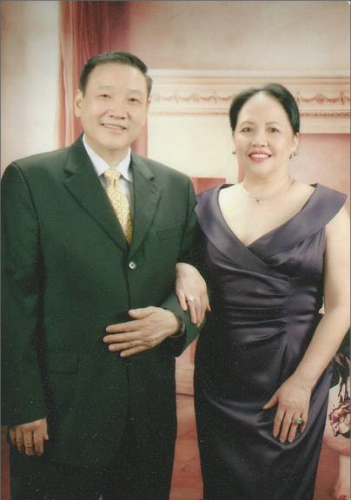

PRESENTED BY
THE HMONG AMERICAN EDUCATION FUND
www.thehaef.org

This scholarship was donated by Dr. Kou Bliaxa Vang and Niam Dr. Kou (Song Lee Vang)

DR. KOU BLIAXA VANG & NIAM DR. KOU (SONG LEE VANG)

LIVING LEGACY SCHOLARSHIP

Dr. Kou Bliaxa Vang and Song Lee came to this country in 1976. They have been together for 41 years. Dr. Vang and Song Lee wed on June 28, 1972. Together they have three sons and three daughters.
Dr. Vang is a Doctor of Dental Surgery and a Lieutenant Colonel in the United States Air Force, Minnesota Air National Guard. He is also the founder of Vang Dental, Inc., and Hmong Minnesota Professionals, LLC.

Dr. Vang is a highly respected individual and leader in the Hmong Community. He has been featured numerous times in the press and in public for his dental work and service in the Minnesota Air National Guard. Despite being grandparents along with running a busy dental practice and service in the Minnesota Air National Guard, Dr. Vang and Song Lee makes every effort to be visible and contributes on a daily basis to the Hmong Community and community at large.

Dr. Kou Bliaxa Vang and Niam Dr. Kou (Song Lee) are the first in the Hmong Community to donate a Living Legacy Scholarship to directly benefit Hmong students. Their generosity, leadership and philanthropy will touch and inspire many students and donors alike for generations to come.

“It is about giving back to your community and the young men and women who will become the leaders of tomorrow,” said Dr. Kou Bliaxa Vang and Song Lee. “It is not about us! We hope our contribution will inspire others to give back to their community wherever they may live.”

(Photo provided by Dr. Kou Bliaxa Vang and Niam Dr. Kou – Song Lee Vang)
Instructions for the Dr. Kou & Niam Dr. Kou (Any Discipline) Scholarship
This scholarship is presented by the Hmong American Education Fund. The scholarship seeks to financially support one student in the pursuit of their educational goals. The successful applicants will be awarded up to $500 to the choice of their college or university in any discipline. Download this application packet and fill out the form below. All application materials are due by April 15. Late applications and materials will not be considered. Any hand written application will be disqualified. All application materials must be emailed to: hmongeducationfund@gmail.com. You will be notified of your application status via email by June 1.
Applicants Must Meet All Criteria Listed
- A U.S. citizen or legal resident alien
- A Minnesota state resident
- Any person of Hmong descent
- All current college and graduate students are eligible
- Has been accepted fulltime to a 2-year or 4-year college/university or graduate school
- Has a minimum GPA of 3.0 in a 4.0 scale system
Scholarship Application Packet, Checklist
- A completed application
- Essay (1500 words or less)
- Copy of unofficial transcript
- One letter of recommendation
- All required application documents should be sent in PDF format via email to hmongeducationfund@gmail.com
A Successful applicant must demonstrate the following
- Pursue an education to better themself and others
- A commitment to excellent academic achievement
- A show of strong leadership qualities
- A commitment to helping your community
- Demonstrated financial needs, or need based on hardships
Essay: In one essay, 1500 words or less, please answer the following questions
- Tell us about your commitment to education
- Tell us some of the things you have done to help your community
- Tell us your needs and how this scholarship can help you
Additional Requirements
- Recipient is expected to attend the Scholarship Awards Banquet on the first Saturday of August.
- If selected, recipients are expected to submit the documents requested for the Scholarship Awards Banquet (ex. photo, bio, thank you letter to donors)
Successful applicants are encouraged to attend two general academic coaching and mentoring sessions with HAEF. These sessions can be done via phone, E-mail or face to face.
( If you have any questions, please email: scholarships@thehaef.org )

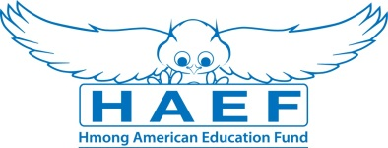
Dr. Kou Bliaxa Vang Scholarship Application
(Type responses below & email back to hmongeducationfund@gmail.com along with all other required documents in PDF)
Last Name: | First Name: |  | Middle:
Home Phone: | Cell Phone: |  | E-Mail:
Gender:  Female Male | Date of Birth (mm/dd/yyyy): |  | Race/Ethnicity:
Current Address:

City: | State: |  | Zip Code:
Permanent Address (if different from above):

City: | State: |  | Zip Code:
Check one of the following:  U.S Citizen  Legal Alien Resident of U.S.  None | Are you a first generation student?  Yes  No |  | Marital Status:  Single  Married  Divorced  Widowed
Number of parent(s): | Family size: |  | Number of dependents (if applicable):
Are you currently in high school or pursuing your GED?
Yes
No
Name of your current School: |  |  | Current GPA:
School Address:

Name of College/University you have been accepted to and/or will be attending:

Major/Program:

Degree you are seeking: Associate BA/BS Masters PhD/Doctorate Other:

What year of schooling are you in: First Year Sophomore Junior Senior

Will you be a Fulltime Student: Yes No
Have you been awarded other scholarships or financial assistance? (If yes, please list them):

Print Name: |  | Signature: |  | Date:
Disclaimer: By signing this application I understand that the information provided is true to the best of my knowledge. HAEF reserve the right to verify information submitted on the successful candidate’s application. In addition, the views and opinions expressed by individuals and/or businesses featured in our scholarships do not necessary represent the views of the Hmong American Education Fund.

