GENERAL VANG PAO SCHOLARSHIP
THE PRAYA NORAPARMORK GENERAL VANG PAO LEADERSHIP LEGACY MEMORIAL SCHOLARSHIP FUND
APPLICATION PACKET
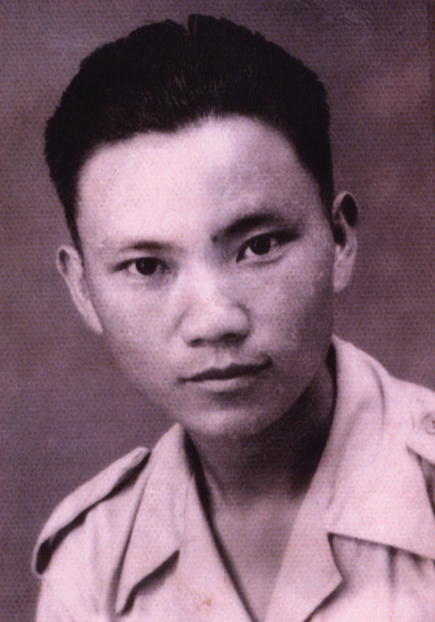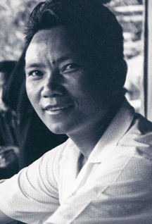

December 8, 1929 – January 6, 2011

PRESENTED BY
THE HMONG AMERICAN EDUCATION FUND
www.thehaef.org

This scholarship was donated by Dr. James Nhia Vang & Mr./Mrs. Chaleunsouk Vang
in loving memory of General Vang Pao.

Vang Pao was born on December 8th, 1929, to Neng Chue Vang and Sao Song Thao in Ha Ta Sheng, Laos close to the border of northeastern Laos and Vietnam. He had eight sisters and two brothers. Four sisters have survived, three of whom resides on the West Coast of the United States, and one in Minnesota. Vang Pao’s father passed away in Laos in 1950 while his mother made the long journey from Laos to America and died in 1981. She was put to rest in the state of Montana.

According to the accounts of family members and elders who lived in the same village as Vang Pao, he was energetic and mischievous, with a mind of his own. Vang Pao was not one to take directions well from his parents and elders. As someone in the 1930s who had no desire to farm, he was in traditional Hmong agrarian society considered lazy and a failure.
Faced with not knowing what to do with his troubled son, Vang Pao’s father decided to send him away from home to be schooled. That would prove to be a pivotal point in Vang Pao’s life. In school, his mind was finally challenged and he saw the world in front of him.
Those who despised Vang Pao in his early years referred to him as “Pov Dag” (a failure). Vang Pao would later prove many people wrong as he progress through his career. Even today, these very same words echo in the Hmong Community and are used as a metaphor in reference to failure and success. From an early age he had two things that were not taught to him it was charisma and a strong will – the will to want to improve the status quo at any cost.
“Just look at Vang Pao,” said Yang Kong. “He went from Pov Dag to general and eventually to Praya Noraparmork (a Royal Lao family title only reserved for dignitaries). If Vang Pao can do it there’s hope that anybody can do it.”
“You can’t judge someone and rule them out as a success or failure until the very end in life,” said Noah Vang, “look at Vang Pao. He struggled all throughout his life to the very end. He had both failure and success all intertwined together. But one thing remains – he never quiet and he remain true to his vision. In the end he achieved the most out of all his family, villagers, classmates, colleagues, and all Hmong of his generation and time.”
“To all students out there,” said Dr. Paozeb Vang in a 1991 speech at the University of Wisconsin-Madison, “remember if anybody should advice or tell you that you can’t do something, tell them yes you can! Just look at our father General Vang Pao. He’s a living proof that you can achieve as much as you want, and that the sky is the limit.”
This Leadership Legacy Memorial Scholarship Fund was made possible by Dr. James Nhia Vang and Mr./Mrs. Chaleunsouk Vang and in loving memory of General Vang Pao.

(Biography and photos provided by the family)

Instructions for the General Vang Pao Scholarship
This scholarship is presented by the Hmong American Education Fund. The scholarship seeks to financially support one student in the pursuit of their educational goals. The successful applicant will be awarded up to $4,000 to the choice of their college or university. Download this application packet and fill out the form below. All application materials are due by April 15. Late applications and materials will not be considered. Any hand written application will be disqualified. All application materials must be emailed to: hmongeducationfund@gmail.com You will be notified of your application status via email by June 1.
Applicants Must Meet All Criteria Listed
- A U.S. citizen or legal resident alien
- Any state resident
- Any person of Hmong descent
- All current college and graduate students attending are eligible
- Have been accepted fulltime to a 2-year or 4-year college/university or graduate school
- Has a minimum GPA of 3.0 in a 4.0 scale system
Scholarship Application Packet, Checklist
- A completed application
- Essay (1500 words or less)
- Copy of unofficial transcript
- One letter of recommendation
- All required application documents should be sent in PDF format via email to hmongeducationfund@gmail.com
A successful applicant must demonstrate the following
- Pursue an education to better themself and others
- A commitment to excellent academic achievement
- A show of strong leadership qualities
- A commitment to helping your community
- Demonstrated financial needs, or need based on hardships
Essay: In one essay, 1500 words or less, please answer the following questions
- Tell us about your commitment to education
- Tell us about your leadership qualities
- Tell us some of the things you have done to help your community
- Tell us your needs and how this scholarship can help you
Additional Requirements
- If the recipient is from Minnesota, he/she is expected to attend the Scholarship Awards Banquet on the first Saturday of August.
- If recipient is not from Minnesota, the donor of this scholarship, Dr. James Nhia Vang will cover airfare cost for the recipient to attend the Scholarship Awards Banquet
- If selected, recipients are expected to submit the documents requested for the Scholarship Awards Banquet (ex. photo, bio, thank you letter to donors)
Successful applicants are encouraged to attend two general academic coaching and mentoring sessions with HAEF. These sessions can be done via phone, E-mail or face to face.
( If you have any questions, please email: scholarships@thehaef.org )

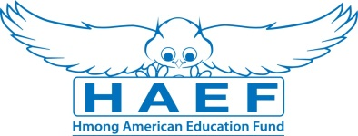
General Vang Pao Scholarship Application
(Type responses below & email back to hmongeducationfund@gmail.com along with all other required documents in PDF)
Last Name: | First Name: |  | Middle:
Home Phone: | Cell Phone: |  | E-Mail:
Gender:  Female Male | Date of Birth (mm/dd/yyyy): |  | Race/Ethnicity:
Current Address:

City: | State: |  | Zip Code:
Permanent Address (if different from above):

City: | State: |  | Zip Code:
Check one of the following:  U.S Citizen  Legal Alien Resident of U.S.  None | Are you a first generation student?  Yes  No |  | Marital Status:  Single  Married  Divorced  Widowed
Number of parent(s): | Family size: |  | Number of dependents (if applicable):
Are you currently in high school or pursuing your GED?
Yes
No
Name of your current School: |  |  | Current GPA:
School Address:

Name of College/University you have been accepted to and/or will be attending:

Major/Program:

Degree you are seeking: Associate BA/BS Masters PhD/Doctorate Other:

What year of schooling are you in: First Year Sophomore Junior Senior

Will you be a Fulltime Student: Yes No
Have you been awarded other scholarships or financial assistance? (If yes, please list them):

Print Name: |  | Signature: |  | Date:
Disclaimer: By signing this application I understand that the information provided is true to the best of my knowledge. HAEF reserve the right to verify information submitted on the successful candidate’s application. In addition, the views and opinions expressed by individuals and/or businesses featured in our scholarships do not necessary represent the views of the Hmong American Education Fund.

